Title

A dissertation presented
by
Name
to
The Department of Name of Department

In partial fulfillment of the requirements for the degree of
Doctor of Philosophy
in the subject of
Subject

Harvard University
Cambridge, Massachusetts
Month Year

© Year Name of Student
All rights reserved

Dissertation Advisor: Dr. PI Name Student Name

Your title in bold as it appears on page 1

ABSTRACT
Your abstract goes here

Acknowledgements
Acknowledgements go here

Table of contents

ABSTRACT iii
Acknowledgements iv
Table of contents v
List of Figures vi
List of Tables vii
Abbreviations viii
Introduction (Heading 1 style) 1
Subtopic 1 (Heading 2 style) 1
Sub-subtopic 1 (Heading 3 style) 1
Subtopic 2 (Heading 2 style) 1
RESULTS (Heading 1 style) 2
Results part 1 (Heading 2 style) 3
Results subpart 1 (Heading 3 style) 3
DISCUSSION (Heading 1 style) 4
Discussion part 1 (Heading 2 style) 4
Discussion subpart 1 (Heading 3 style) 4
METHODS (Heading 1 style) 5
Methods part 1 (Heading 2 style) 5
Methods subpart 1 (Heading 3 style) 5
APPENDIX 1 (Heading 1 style) 6
Appendix part 1 (Heading 2 style) 6
Appendix subpart 1 (Heading 3 style) 6
REFERENCES (Heading 1 style) 7

By using the heading 1, 2, etc. styles, Word will automatically create a table of contents for you. Note that the highlighting in this table will disappear as you un-highlight your section headings.

List of Figures
Figure 1- Sample figure (Caption style). 1

If done correctly, your list of figures here will match exactly to your text. Note that the highlighting in this list will disappear as you un-highlight your captions.

List of Tables
Table 1- Styles (Caption style) 1
Table 2- List of primers 5
Table 3- PCR thermocycler settings 5

If done correctly, your list of tables here will match exactly to your text. Note that the highlighting in this list will disappear as you un-highlight your captions.

Abbreviations
List your abbreviations here

Introduction (Heading 1 style)
Start your text here. This will mostly likely be an introduction. Use the format below to subdivide into different sections as needed

Subtopic 1 (Heading 2 style)

Sub-subtopic 1 (Heading 3 style)

Sub-sub-subtopic 1 (Heading 4 style)

Subtopic 2 (Heading 2 style)
Continue with this formatting to end of introduction

Table 1- Styles (Caption style)
Style | Font | Size | Other
Heading 1 | Calibri | 16 1st letter, 14 rest | Bold
Heading 2 | Calibri | 14 | Bold
Heading 3 | Calibri | 12 | Bold
Heading 4 | Calibri | 12 | Bold and italics
Caption | Calibri | 10 | Bold
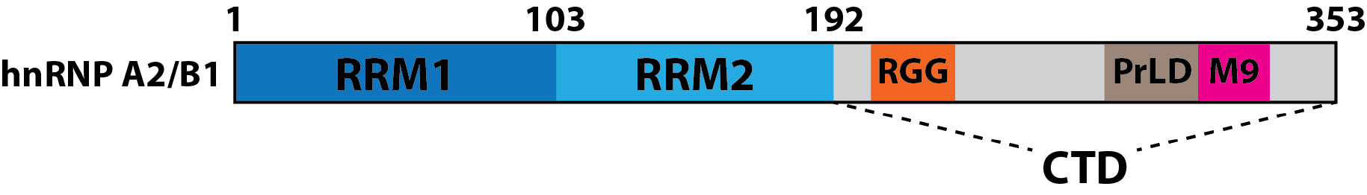
Figure 1- Sample figure (Caption style).
Sample caption (Normal style)

RESULTS (Heading 1 style)
List who did what work.

Results part 1 (Heading 2 style)

Results subpart 1 (Heading 3 style)
Write out your results following the same heading style format as in the introduction. Depending on your thesis, you may have multiple results chapters.

DISCUSSION (Heading 1 style)

Discussion part 1 (Heading 2 style)

Discussion subpart 1 (Heading 3 style)
Write out your discussion following the same heading style format as in the introduction/results.

METHODS (Heading 1 style)

Methods part 1 (Heading 2 style)

Methods subpart 1 (Heading 3 style)
Write out your methods following the same heading style format as in the introduction/results.
A sample on how to list primers is found in Table 2.
Table 2- List of primers
Bolded nucleotides refer to restriction enzyme sites. Nucleotides in red and underlined refer to either the stop codon, or control codon. Pi represents a phosphorylated nucleotide.
Construct | Direction | Sequence
TGA only | fwd | 5'- Pi-GATCC TTGA GAGCT -3'
TGA only | rev | 5'- Pi-C TCAA G -3'
GCA only | fwd | 5'- Pi-GATCC TGCA GAGCT -3'
GCA only | rev | 5'- Pi-C TGCA G -3'

A sample PCR protocol is shown in Table 3
Table 3- PCR thermocycler settings

Temperature |  | Time
94°C |  | 3 minutes
35X | 94°C | 15 seconds
35X | 55°C | 30 seconds
35X | 72°C | 45 seconds
72°C |  | 12 minutes

APPENDIX 1 (Heading 1 style)

Appendix part 1 (Heading 2 style)

Appendix subpart 1 (Heading 3 style)
YOU MAY NOT NEED THIS SECTION
Write out your appendices following the same heading style format as before.

REFERENCES (Heading 1 style)
Pick your favorite citation manager and format to add all your references here.

