Zoom Defense Instructions
- Zoom Setup
  - Links: Lindsay (MCO Program Coordinator) will create 2 Zoom links, one for the public portion of the defense (which will be advertised to the community), and one for the private portion of the defense.
  - Passwords: A password will also be created for both defenses. The password for the public defense will be shared with the departmental announcement, and may be distributed to invited attendees. The password for the private defense will be shared just with the student/advisor/committee.
  - Hosting: For both meetings, the student and advisor will be designated as the alternative hosts in advance. The host(s):
    - Must have a Harvard Zoom account.
    - Will start the meeting (ideally prior to the scheduled time).
    - Will be in charge of certain controls (see below).
  - Other:
    - All participants will be muted when they join the meeting. They may un-mute themselves to ask questions at the end of the presentation.
    - Sounds when participants join or leave have been disabled to minimize disruptions
    - Lindsay will maintain hosting capabilities and will attend all public defenses. She will assist should any issues arise.
- Public Defense
  - Participants can join the defense prior to the start time, so it’s important to start the Zoom meeting early to make sure everything is functional.
  - Everyone who is designated a host will be able to share their screen, but participants cannot.
  - To answer any questions at the end of the defense, participants can either enter questions in the chat window, or raise their hands (found in the Manage Participants window, see below). If using the hand-raising method, participants will need to unmute themselves.

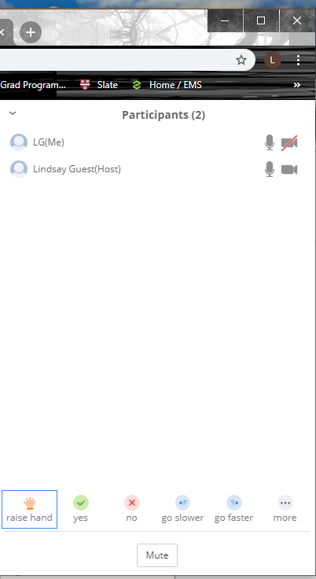

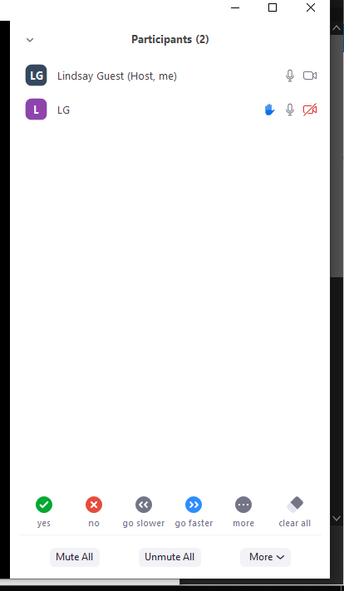

Host view
Participant view

- Private Defense
  - At the end of the public defense, the student and committee will leave the meeting and join the private Zoom meeting.
  - In order for the committee to engage in private discussions during the defense, the host can put the student “on hold” at anytime by doing the following:
  - Click on “Manage Participants at bottom of screen
  - Next to the person you want to put on hold, click “More”.
  - Select “Put on Hold”.

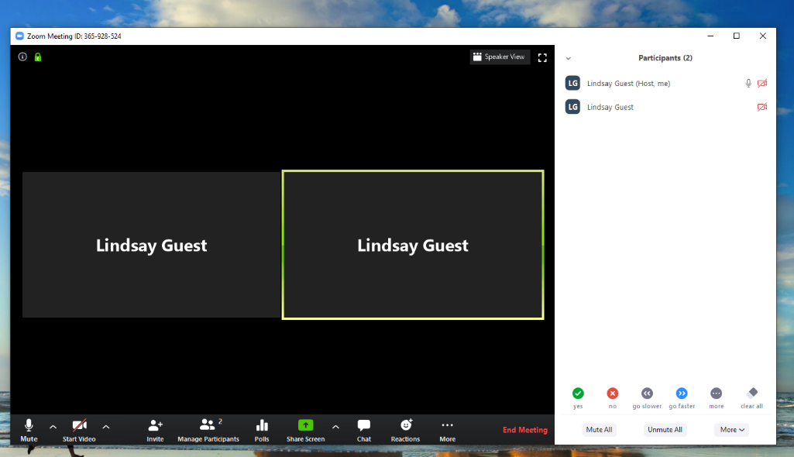
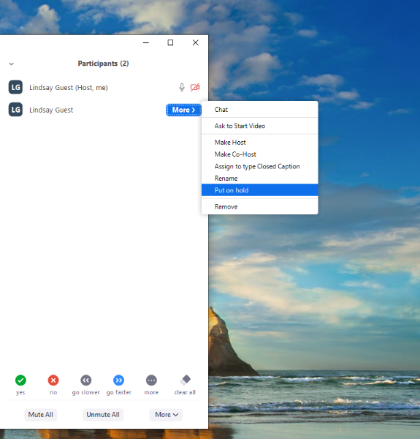

- The paricipant will not be able to see or hear the meeting, and will see the following screen while on hold:
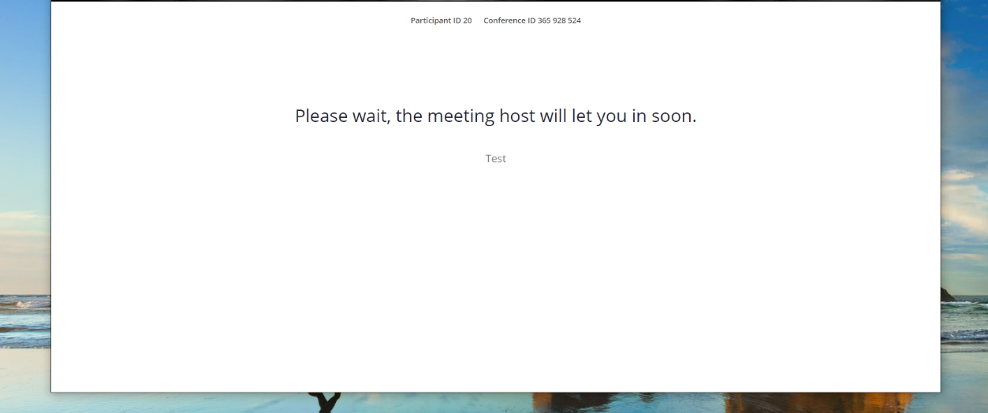

- To bring the participant, back, click “Take Off Hold”
